SQL Sense Checks (Finance Project)
- Sample Rows
SELECT *
FROM `projectspractice12.sp500dataAnalysis.sp500data`
LIMIT 5;

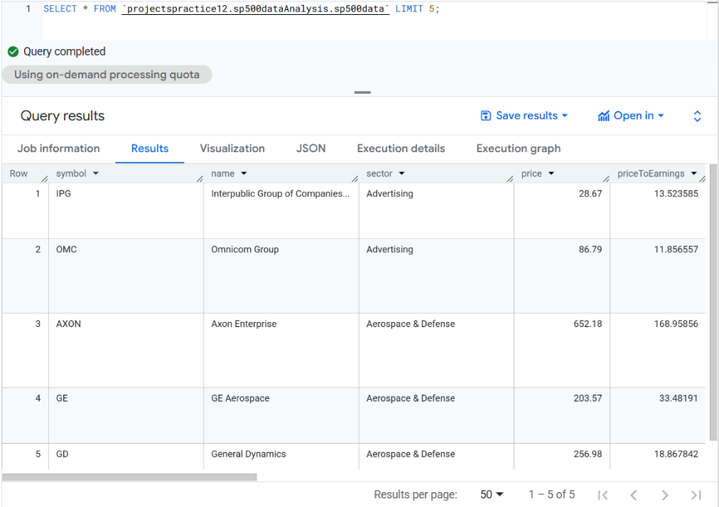
- Row and Symbol Counts

SELECT
COUNT(*) AS row_count,
COUNT(DISTINCT symbol) AS ticker_count
FROM `projectspractice12.sp500dataAnalysis.sp500data`;

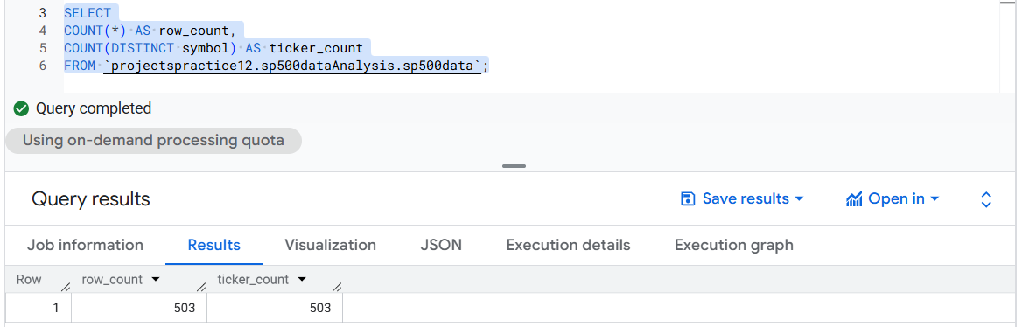

- Null values
SELECT
SUM(CASE WHEN symbol IS NULL THEN 1 ELSE 0 END) AS null_symbol,
SUM(CASE WHEN name IS NULL THEN 1 ELSE 0 END) AS null_name,
SUM(CASE WHEN sector IS NULL THEN 1 ELSE 0 END) AS null_sector,
SUM(CASE WHEN price IS NULL THEN 1 ELSE 0 END) AS null_price,
SUM(CASE WHEN priceToEarnings IS NULL THEN 1 ELSE 0 END) AS null_pe,
SUM(CASE WHEN dividendYield IS NULL THEN 1 ELSE 0 END) AS null_div_yield,
SUM(CASE WHEN EarningPerShare IS NULL THEN 1 ELSE 0 END) AS null_eps,
SUM(CASE WHEN WeekLow52 IS NULL THEN 1 ELSE 0 END) AS null_wk_low,
SUM(CASE WHEN WeekHigh52 IS NULL THEN 1 ELSE 0 END) AS null_wk_high,
SUM(CASE WHEN marketCap IS NULL THEN 1 ELSE 0 END) AS null_mktcap,
SUM(CASE WHEN ebitda IS NULL THEN 1 ELSE 0 END) AS null_ebitda,
SUM(CASE WHEN PriceToSales IS NULL THEN 1 ELSE 0 END) AS null_ps,
SUM(CASE WHEN priceToBook IS NULL THEN 1 ELSE 0 END) AS null_pb,
FROM `projectspractice12.sp500dataAnalysis.sp500data`;

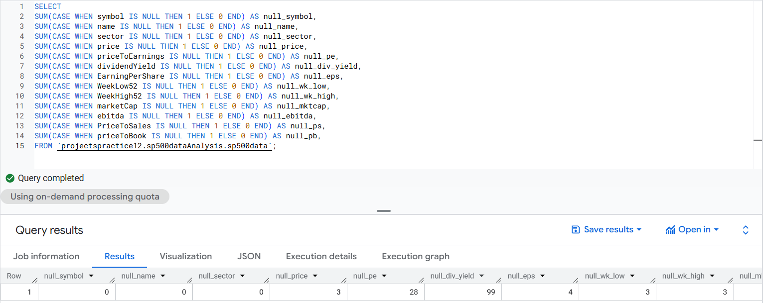

- Range
SELECT
MIN(price) AS min_price,
MAX(price) AS max_price,
MIN(priceToEarnings) AS min_pe,
MAX(priceToEarnings) AS max_pe,
MIN(dividendYield) AS min_div_yield,
MAX(dividendYield) AS max_div_yield,
MIN(EarningPerShare) AS min_eps,
MAX(EarningPerShare) AS max_eps,
MIN(WeekLow52) AS min_wk_low,
MAX(WeekHigh52) AS max_wk_high,
MIN(marketCap) AS min_mktcap,
MAX(marketCap) AS max_mktcap,
MIN(ebitda) AS min_ebitda,
MAX(ebitda) AS max_ebitda,
MIN(PriceToSales) AS min_ps,
MAX(PriceToSales) AS max_ps,
MIN(priceToBook) AS min_pb,
MAX(priceToBook) AS max_pb
FROM `projectspractice.sp500dataAnalysis.sp500data`;

